SHRI VAISHNAV VIDYAPEETH VISHWAVIDYALAYA

Notification: SVVV/N-083/2019

FORM-II

Date: / / 2020

**INDUSTRY MENTOR EVALUATION OF INTERN**

**(To be printed on Organization Letter Head)**

Student Enrolment No: Name:

Internship Address:

Dates of Internship Evaluation: From To Duration

Please evaluate your intern by indicating the frequency with which you observed the following on a 10-point scale -

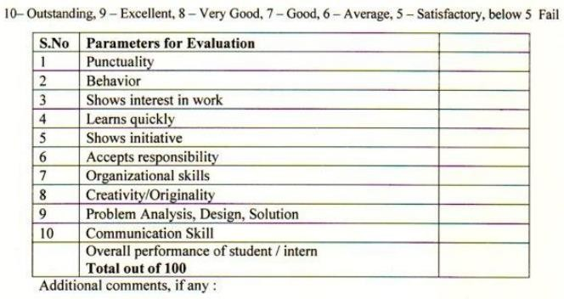



Campus: Ujjain Road Indore Indore 453111 Phone +91-731-2729071-5 Website: [www.svvv.edu.in](http://www.svvv.edu.in/) Mailing Address: Shri Vaishnav Vidya Parisar 177 Jawahar Marg, South Rajmohalla, Indore, M.P. – 452002 Phone: +91-731-2349111-2 Fax: +91-731-2349113